Unit 7 Final Project
Name
Institution
Date

Unit 7 Final Project

Design

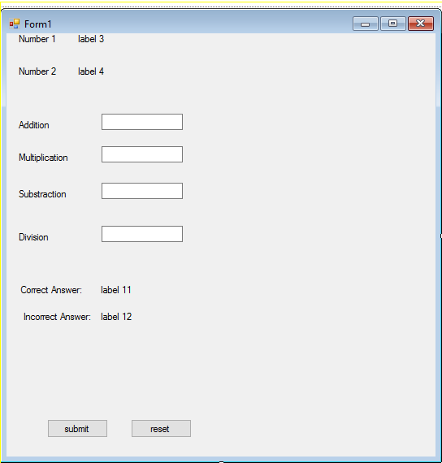

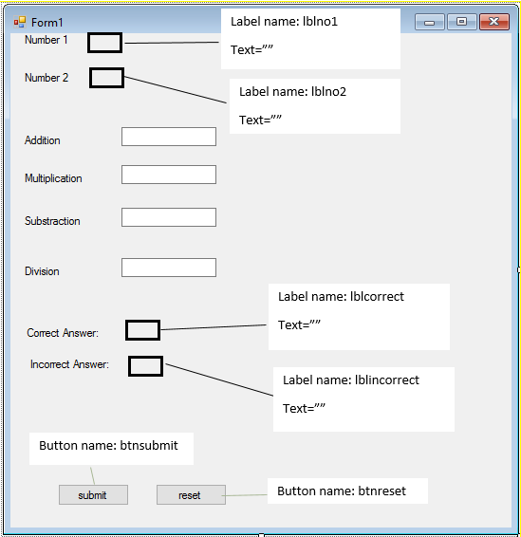

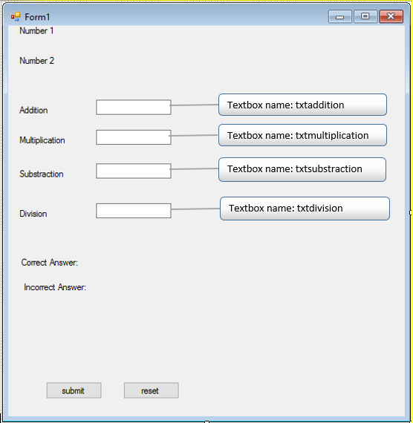

Coding

Public Class Form1
Dim num1 As Integer
Dim num2 As Integer
Dim add As Integer
Dim mul As Integer
Dim div As Integer
Dim sub1 As Integer
Dim correct As Integer = 0 ' default zero
Dim incorrect As Integer = 0 ' default zero

Private Sub Form1_Load(ByVal sender As System.Object, ByVal e As System.EventArgs) Handles MyBase.Load
Dim Generator As System.Random = New System.Random() 'object for generating random number
num1 = Generator.Next(1, 20) 'store in num1
num2 = Generator.Next(1, 20) 'store in num2
lblno1.Text = num1.ToString 'display output
lblno2.Text = num2.ToString 'display output
add = num1 + num2 'calculate
sub1 = num1 - num2 'calculate
mul = num1 * num2 'calculate
div = num1 / num2 'calculate
lblcorrect.Text = correct.ToString 'display output
lblincorrect.Text = incorrect.ToString 'display output

End Sub

Private Sub Button1_Click(ByVal sender As System.Object, ByVal e As System.EventArgs) Handles btnsubmit.Click
If (add = Val(txtaddition.Text)) Then 'validation of ans
correct += 1 'increment if correct
Else
incorrect = incorrect + 1 'increment if incorrect

End If
If (mul = Val(txtmultiplication.Text)) Then 'Validation of ans
correct += 1 'increment if correct
Else
incorrect = incorrect + 1 'increment if incorrect
End If
If (div = Val(txtdivision.Text)) Then 'validation of ans
correct += 1 'increment if correct
Else
incorrect = incorrect + 1 'increment if incorrect
End If
If (sub1 = Val(txtsubstrction.Text)) Then ' validation of ans
correct += 1 'increment if correct
Else
incorrect = incorrect + 1 'increment if incorrect

End If
lblcorrect.Text = correct.ToString 'dipsplay output
lblincorrect.Text = incorrect.ToString 'display output
Form1_Load(sender, e)
txtaddition.Text = ""
txtdivision.Text = ""
txtsubstrction.Text = ""
txtmultiplication.Text = ""
End Sub

Private Sub btnreset_Click(ByVal sender As System.Object, ByVal e As System.EventArgs) Handles btnreset.Click
txtaddition.Text = ""
txtdivision.Text = ""
txtsubstrction.Text = ""
txtmultiplication.Text = ""
lblcorrect.Text = ""
correct = 0
lblincorrect.Text = ""
incorrect = 0

End Sub
End Class

Output:
